**Facilities Maintenance Portal Software Specification**

## Document Purpose

The purpose of this project is to build a data-driven web application that delivers quality on-demand and scheduled maintenance service while lowering overall costs. The application will allow customers to place work order requests and also allow employees to respond to those requests.

## Intended Audience

This document is intended for mainly for the owners of this multi-site facilities maintenance and repair specialist company. End-users/customers, data architects, application architects, and technical architects would also find the information in this document useful.

## Project Background

These business requirements are not a result of previous meetings or correspondencies etc.

## 1.1 Purpose of the Business Requirements

These are business requirements for a new application development. The purpose of these business requirements is to show our client the different features or functionality that’s going to be supported in this web portal.

## 1.2 Business Goals/Objectives to be achieved

Our goal is to create a system that will enhance the productivity of the company and also reduce the stress on the customers when they need to make work order requests

## 1.3 Benefits/Rationale

The problem with the current system is that the paper work order transactions are inefficient and also increases costs since so many human and non human resources are involved in this process. Our project aims to expedite the process by developing a facilities management well portal that Will be more efficient and less costly. This will be the major benefit to be achieved with the implementation of the Business Requirements.

1. State the major benefits that the implementation of these Business Requirements will result in. Mention both tangible and intangible benefits expected.

## 1.4 Stakeholders

The stakeholders for this project are customers and company employees. Customers will find this application useful because it will allow them to request maintenance services in a hustle free manner. Employees will benefit from this portal because this technology will help them easily take, handle, and follow up on orders and their customers. Such a service will lead to high levels of customer satisfaction and also high profits for the company.

## 1.5 Assumptions

The assumptions that we have made prior to or during the Business Requirements gathering and documentation are:

* Customers have to file paper work order requests
* The company spends a lot of money on paper and processing of people through its employees

# Functional Requirements

In this section we describe the functional requirements part of the business requirements.

## 2.1 Actor Profiles Specification

In this section we describe the Actors and their profiles within the context of the Business Requirements being documented. In our project we have two actors and these are employees and customers. Their goals or behavior is represented by our use case diagrams below.

## 2.2 Essential Use Case Diagram

This section depicts the Business Requirements n the form of Essential Use case diagram. In this approach, our functional requirements will be decomposed into a number of Essential use cases.

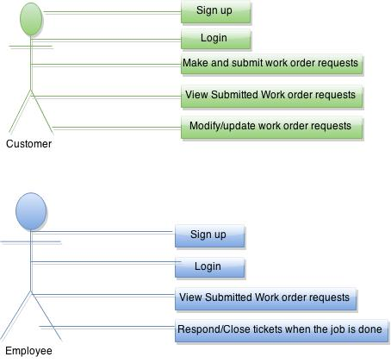

## 2.3 Essential Use Case Specifications

The basic requirements of the system are that the system must be able to allow customers to submit their work order requests, and also allow employees to respond to those requests.

**Primary actors:** Customers and Employees.

**Preconditions:**

* There is an internet connection and actors are able to access the portal
* The portal is working well

**Basic flow of events when a customer interacts with the system:**

1. Signup (if the customer hasn’t done this before)
2. Login
3. Make and submit work order requests
4. View submitted work order requests (if at least one request has been submitted previously)
5. Modify/update work order requests (if at least one request has been submitted previously)

**Basic flow of events when an employee interacts with the system:**

1. Signup (if the an employee hasn’t been added to the company’s database already)
2. Login
3. View submitted work order requests (if at least one request has been submitted previously by a customer)
4. Respond /close tickets when the job is done or when a technician is sent to do the job

## User Interface Requirements

In this section we describe User Interface requirements for this system. Since we this system depends on two main actors namely Employees and Customers, our User Interface requirements will also focus on these actors.

**3.1 Homepage for the Portal (UI for both Customers and Employees)** 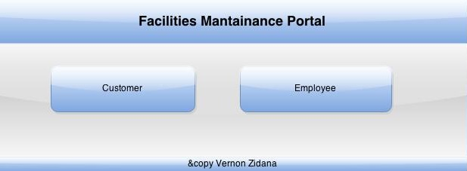

**3.2 Employee User Interface Requirements**

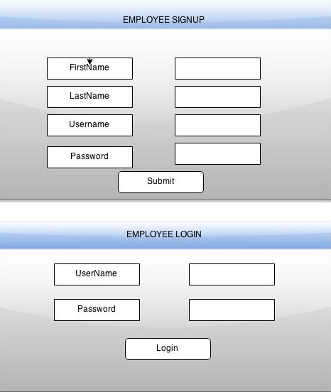

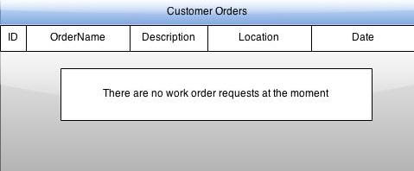

**3.3 Customer User Interface Requirements**

